Professional High School

**SECOND QUARTER**

**ICT 9 Project – Cascading Style Sheets (30points)**

NAME: _________________________________________________________________________ SCORE: _______________

GRADE AND SECTION: _________________________ DATE: __________________

**DIRECTIONS:**

1. Create a website menu of your favorite restaurant.
2. Insert the following HTML Elements:

* Text
* Images
* Tables
* Forms
* Hyperlinks

1. Apply the following CSS property:

* background-color
* color
* letter-spacing
* text-shadow
* text-decoration
* border-style
* border-width
* border-color
* margin
* padding

1. Save your files following the format:

* **CAMPUS_ICT9Section_Q2Project_LastName_FirstName.html**

1. Upload your website in GitHub.
2. Submit the repository and website link in our ICT VN submission bin.

**SAMPLE OUTPUT:**

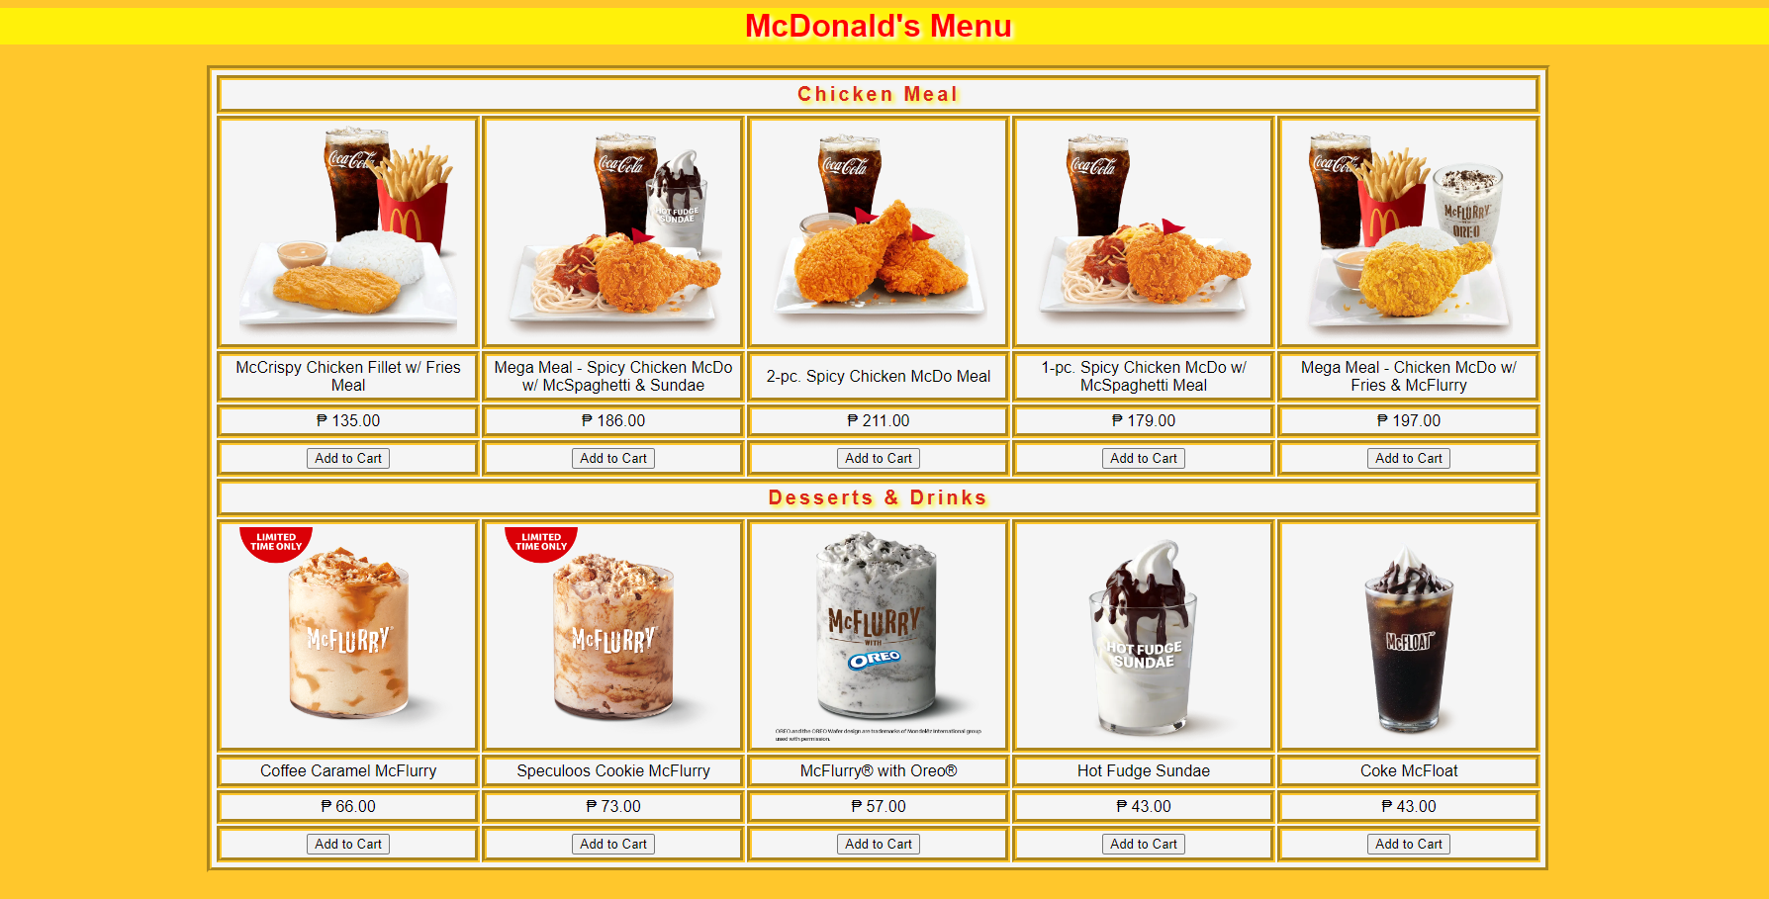

CRITERIA:

|  |  |  |  |  |  |
| --- | --- | --- | --- | --- | --- |
|  | **E = 6** | **AS = 5** | **S = 4** | **NI = 2** | **P = 1** |
| **Execution of Instructions** | Executed the instructions efficiently. Followed the procedures accurately. | Followed most of the instructions. One instruction is skipped; however, it does not affect the over-all output. | The activity shows the basic CSS Design.  There are two to three errors in the activity. | The activity is missing important contents due to omission of four to five instructions. | The activity is full of technical errors due to misinterpretation of all instructions. |
| **Format / Layout** | All the contents are organized and presented in a uniform format with distinctions between major contents and supporting details. | Most contents are organized and well presented. Formatting where necessary is applied. However, one formatting requirement is missing. | The major contents are formatted; however, two to three formatting requirements are missing. | The activity contains formatting; however, four to five formatting requirements are missing. | The activity was laid out poorly. Contents are not placed in proper order. All formatting requirements are missing. |
| **Accomplished task within the time limit.** | The activity was completed before the allotted time elapsed. | The activity was completed within the given time. | The activity was not completed within the given time. A five-minute extension was given in order to complete the activity. | The activity was not completed within the given time. A ten-minute extension was given in order to complete the activity. | The activity was not completed within the given time. A fifteen-minute extension was given in order to complete the activity. |
| **Creativity / Originality** | Exercises creativity. Design goes above and beyond the requirement. | Applies original design in most aspect of the activity. | The activity is presented with some unique design details. | Lacks originality. Design is a duplicate of the sample. | Failed to create even the simplest design for the activity. |
| **General Output** | Pre-planning and proper execution is very evident. All requirements for the activities are evident in the final output. | The activity contains one minimal inaccuracy is observed; however, it did not affect the over-all output. | Two to three major components of the activity are missing. | The activity is very simple and lacks effort in most areas. Four to five components of the activity are missing. | The activity has no impact at all. All major components of the activity are missing. |

CODES:

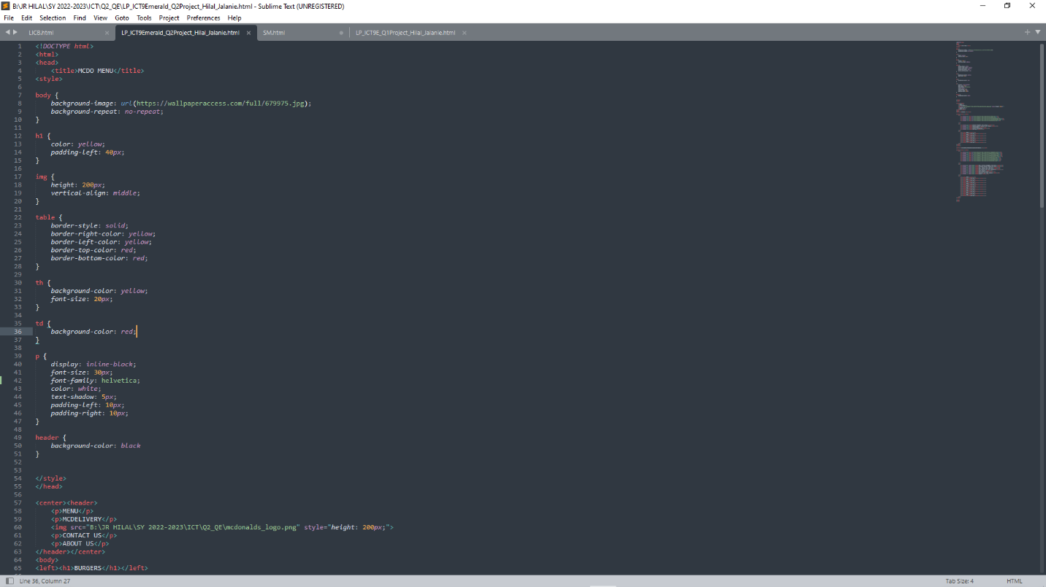

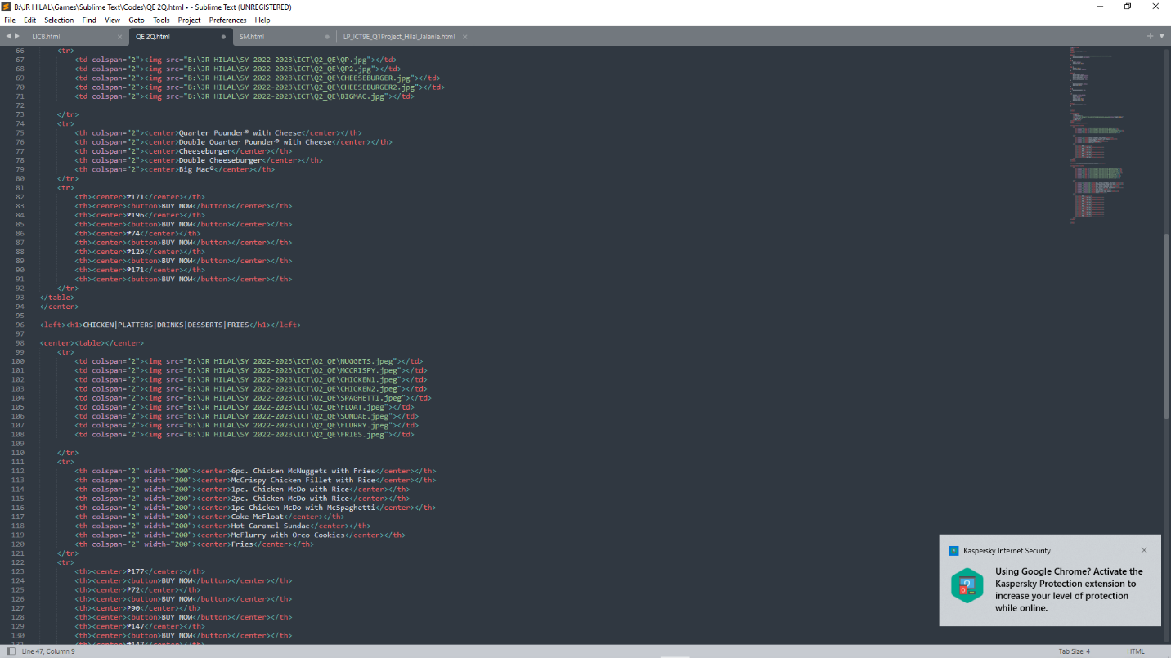

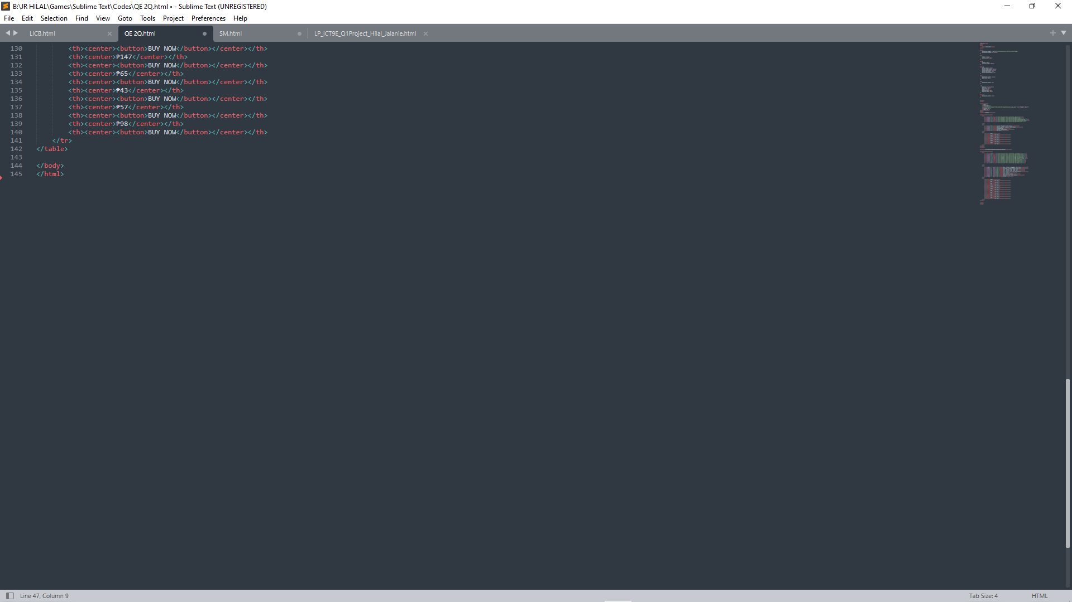

OUTPUT:

